APP SERVER AND WEB SERVER

1.Install nginx and run on port number 81.
We use yum install nginx to install.
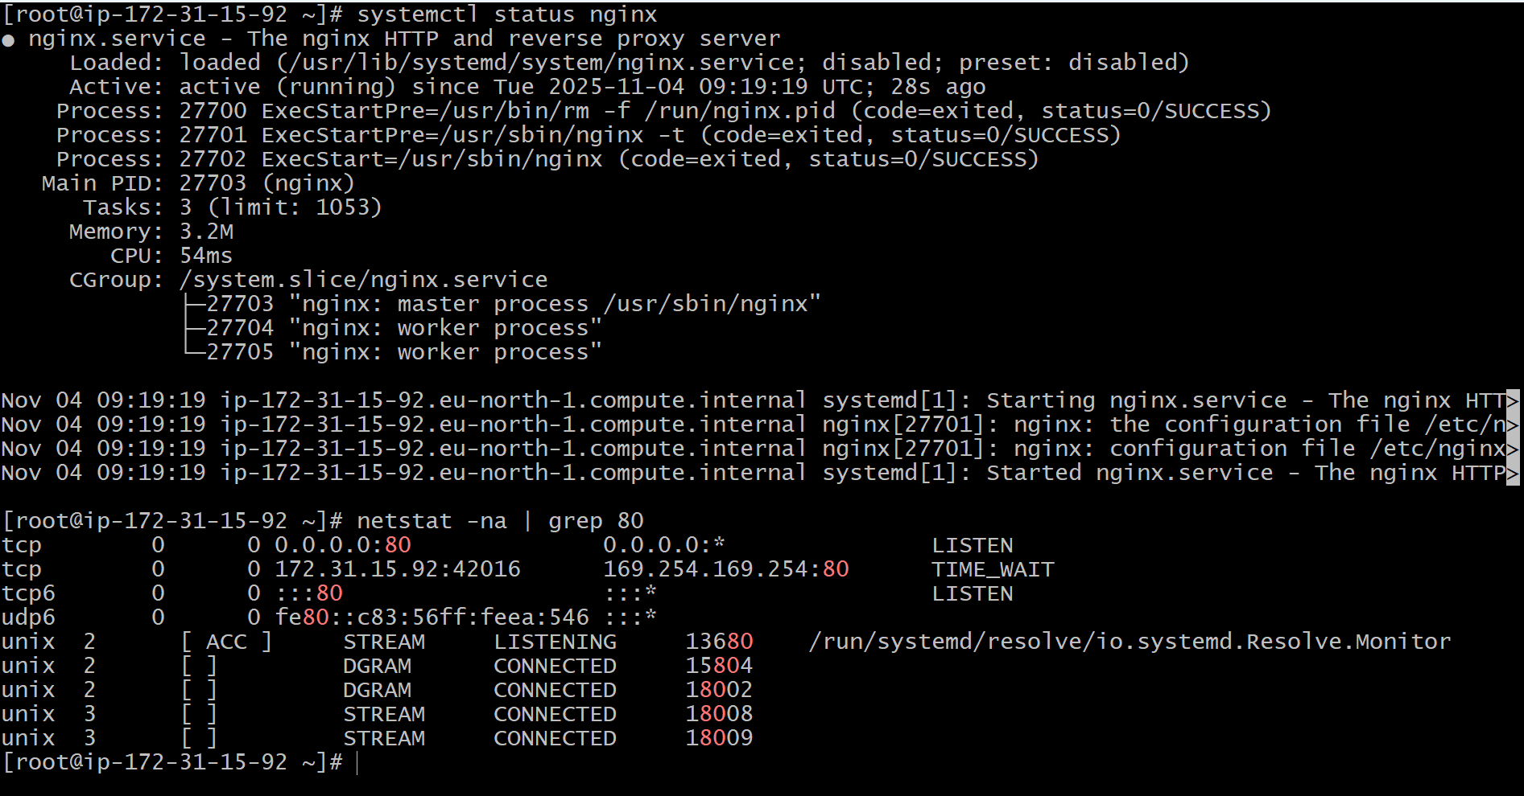
Port number changed from 80 to 81.

2.Deploy a sample index.html file on nginx.


3.Install Apache and run on port number 82.

yum install httpd - To install Apache
systemctl start httpd to start the service.
Sytemctl status to check the service status.
And paste the publicip:80 in browser it works.

After changing the port number to 82
Systemctl restart httpd to restart the service.
And paste the publicip:82 in browser it works.

4.Deploy a sample index.html file on Apache.
We need to deploy in /var/www/html location.
There we need to create an empty file and should edit that file.


5.Install Apache tomcat on port number 8082.
To intsall Apache from browser we need to give wget command and paste the link in ec2.
After that we need to untar the downloaded one.
Bash startup.sh is used to check weather it is running or not.
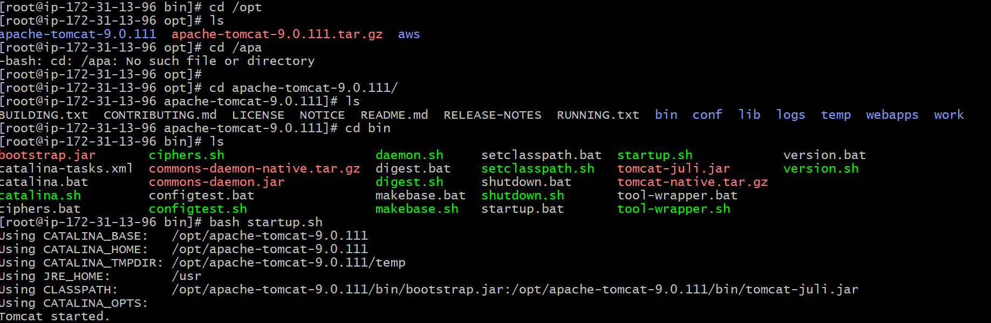

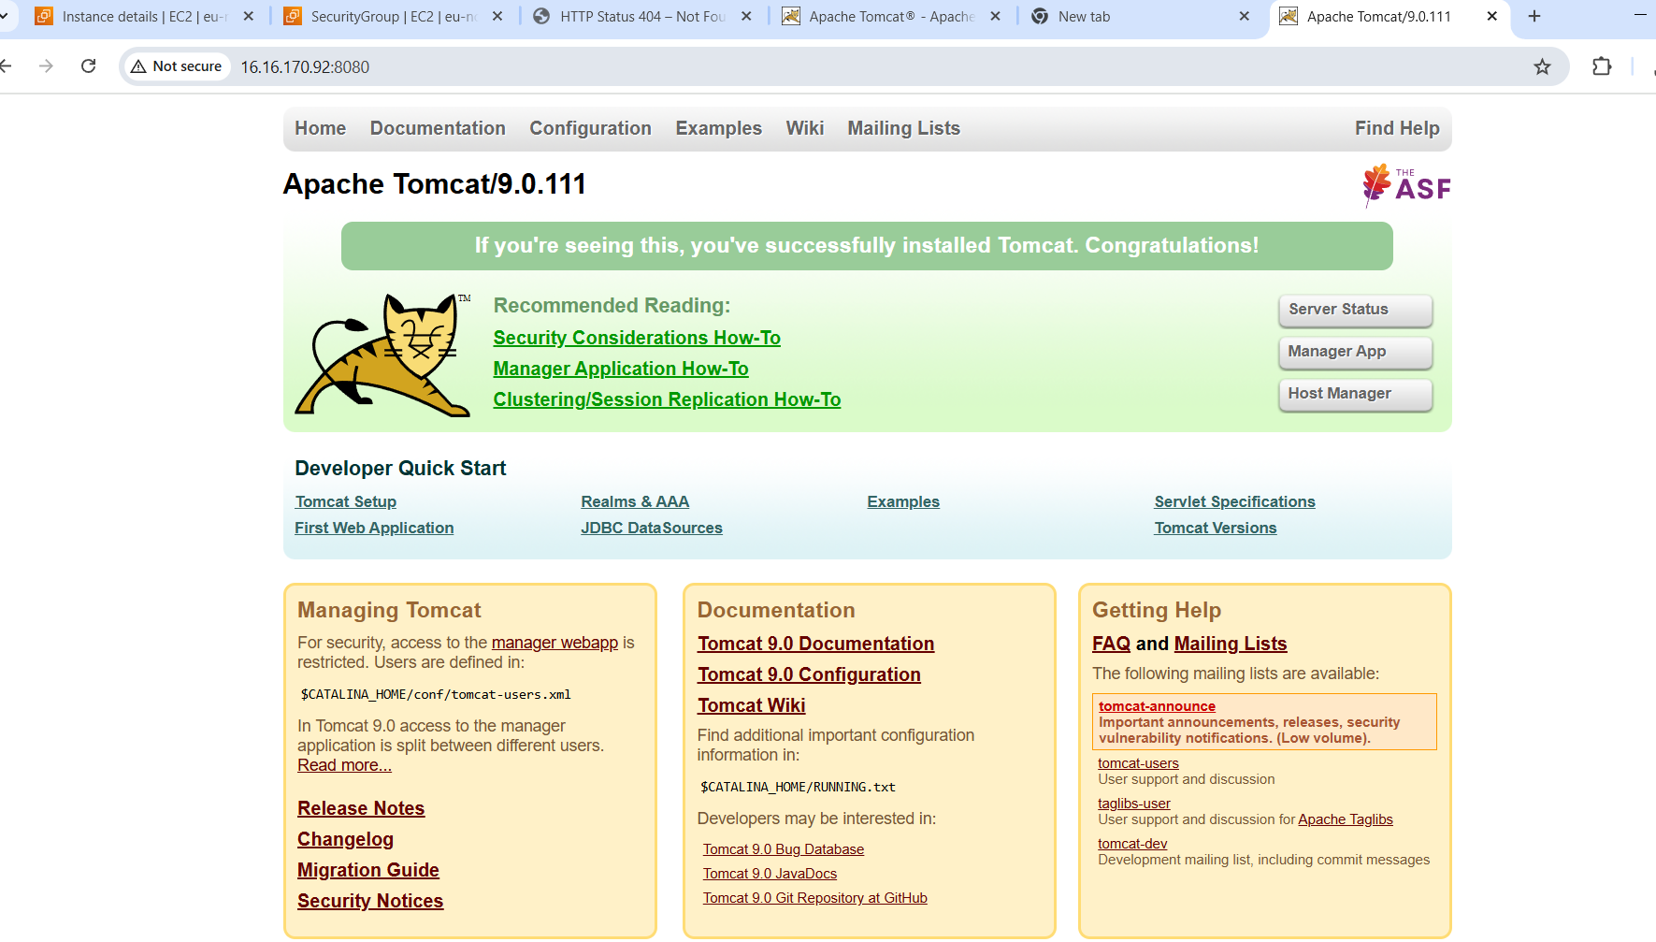
We need to change the port number in conf/.
To find the port number check for server.xml.
Then to edit the file vi server.xml.
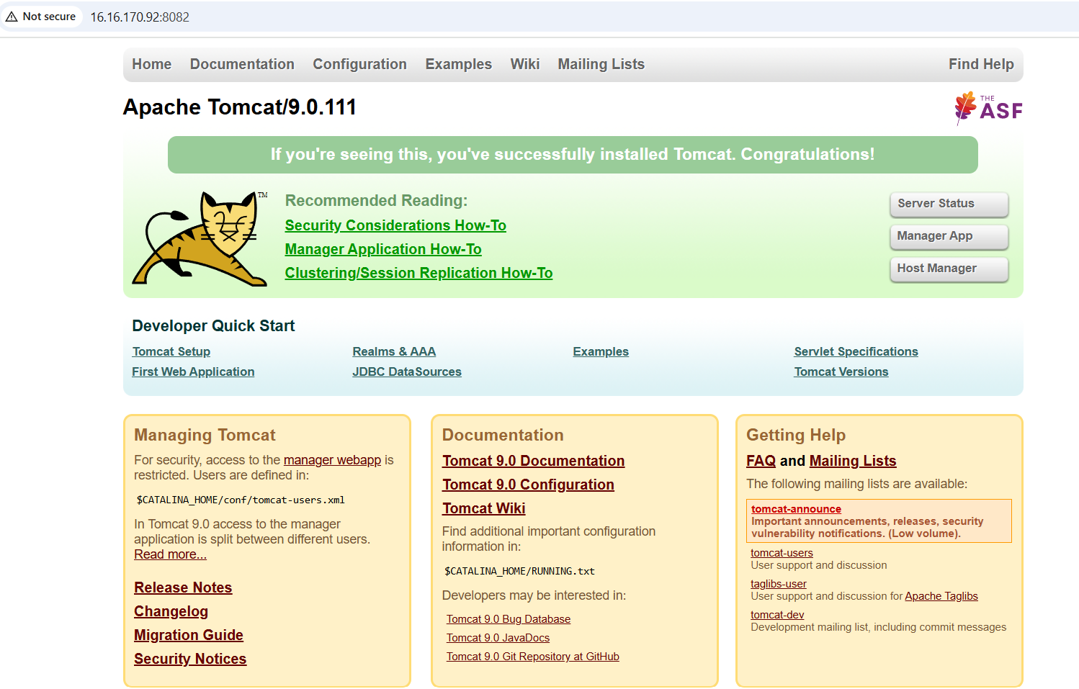

6.Deploy a sample app on web apps.
We need to go to webapps location to deploy any application.
After that copy link address from the sample.War in internet and wget and paste the link address. And if we do ll we get the sample,paste that in internet.
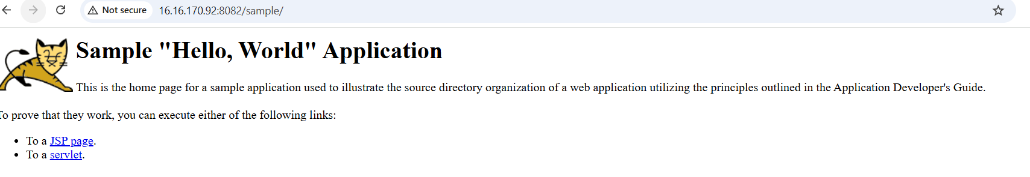

7.Create a tomcat.service file for tomcat.

First we need to to etc and systemd and system and after ceating a service file we should edit the service file.
Systemctl demoan reload
Systemctl start tomcat
Systemctl enable tomcat
Systemctl status tomcat
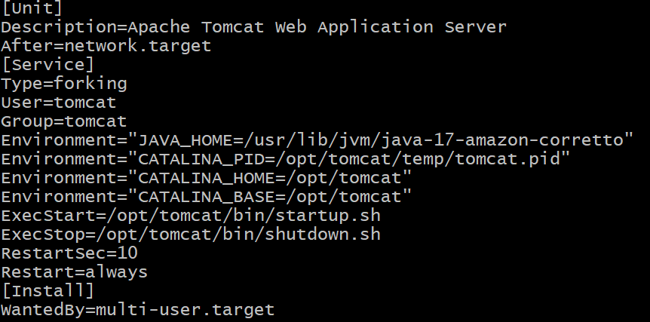

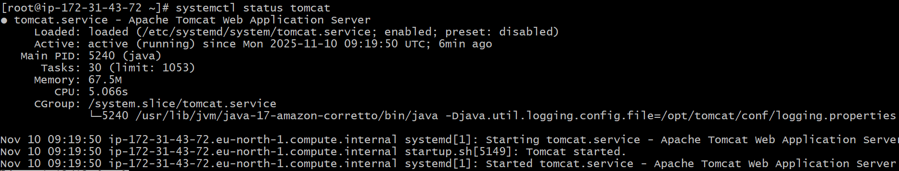

8.Configure a HA proxy server.
First we need to create three ec2 instances.
In one server we need to install nginx -server1.
In second one we need to install httpd-server2.
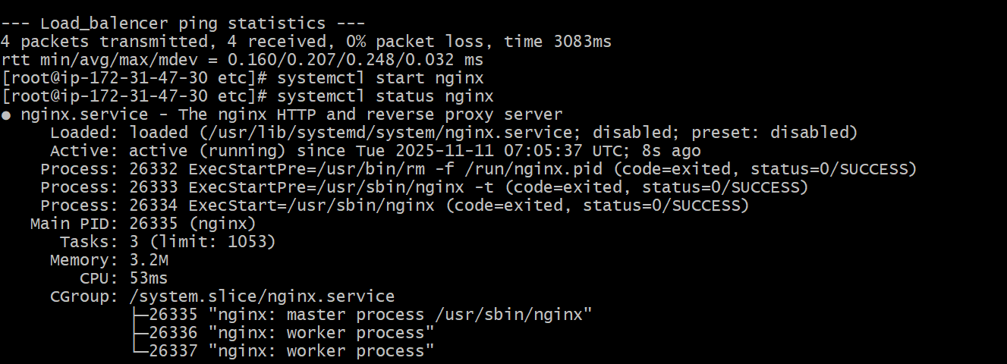
cd /etc and later vi hosts we need add public ip and check in the browser.
Server 2 httpd
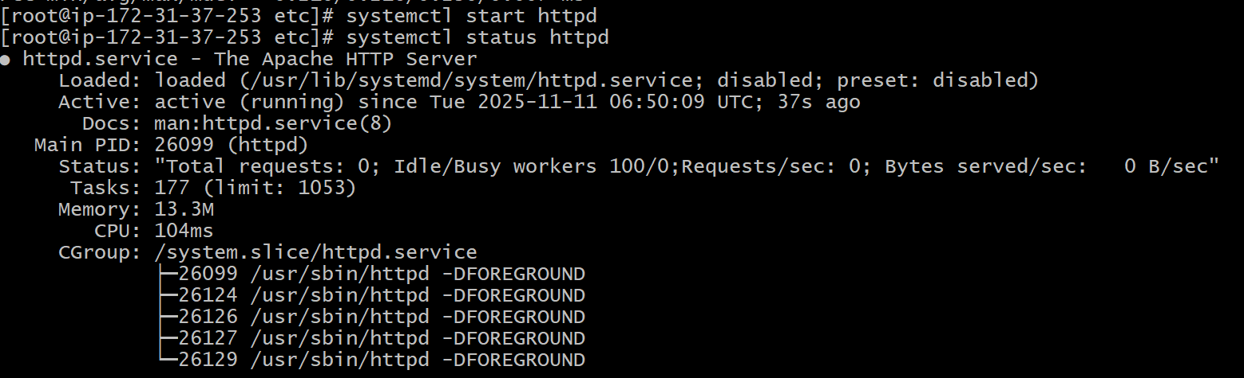
Again we should go to vi and edit the public ip.
And in the third instance we should install ha proxy.
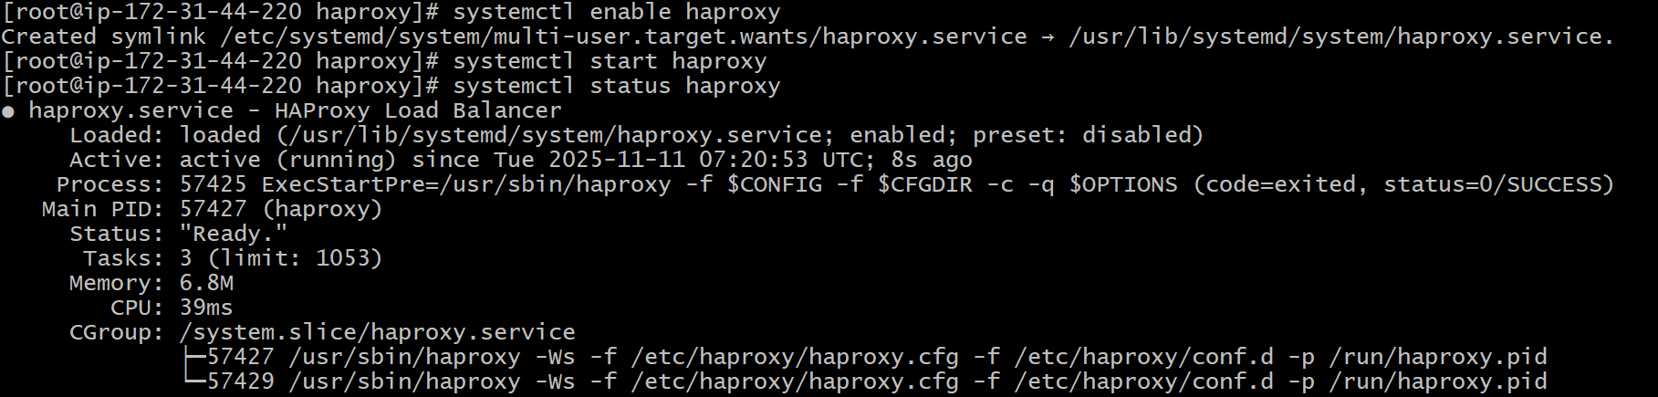
Now after going to etc we should edit in hosts both server 1 and 2 public ips.
Vi etc/haproxy/haproxy.conf edit the server 1 and 2 ips.
Systemctl enable haproxy
Systemctl start haproxy
Systemctl status haproxy.
And finally check in the browser.


